**Ice Sheet Density Data At and Around Summit Station (GRIP/GISP2)**

K. Jezek

July 1014

The Ohio State University conducted geophysical studies before and after the deep drilling at GISP2 (the US drilling program) and the nearby GRIP site (European deep drilling project). Density data are summarized here. Data files are linked to the UWBRAD web page.

Depth-density profile, GISP2 1989, Prepared by R.B. Alley.

Attached is a provisional depth-density profile for leg 2 of the 1989 GISP2 season. Data used include: a) detailed snow-density-tube sampling from my science pit (top 2 m); b) one-meter samples from cores A (3-32 m), B (2-96 m and 119-120 m) and C (1-16 m and 59-85 m), measured by most members of the core-processing line; and c) isostatic weighing of ice in isooctane. Other pit densities (by P. Grootes, P. Mayewski, C. Kingma, or ??) are not included, T. Sowers' detailed densities across pore close-off are missing, and any leg-3 densities (from 16-59 m on core C, from any other cores drilled) are absent. Point-count densities from thin sections are not available yet. Addition of further data will illustrate density variations, but is unlikely to change the overall curve significantly.

The volume-mass method probably underestimated densities of deeper samples, because the ice was sufficiently trashed that reassembling was difficult and some air was included in most meters. Isostatic weighing should overestimate densities in the shallowest ice, because the fluid enters some pores opened to the surface by drilling. This latter effect should be quantifiable once thin-section data are reduced. The smoothed curve on the figure was drawn to ``split the difference'' on these errors; if the depth-density profile is smooth (virtually all known examples are) then there really is little latitude in drawing the curve.

The smoothed depth-density curve was drawn by inspection and by hand, and numerical values were then read off of it; these values are tabulated below. Increments are 1 m long from 0 to 100 m depth, and 10 m long from 100 to 200 m depth. Shown are the midpoint depth (m) for an increment, the midpoint density (kg/m$"" sup 3$), and the load (kg/m$"" sup 2$) at the bottom of the increment. For example, from 15 to 16 m depth, the midpoint is 15.5 m, the density at 15.5 m is 554 kg/m$"" sup 3$, and the load at 16 m is 7310 kg/m$"" sup 2$. Similarly, from 110 to 120 m depth, the midpoint is 115 m, the density at 115 m is 896 kg/m$"" sup 3$, and the load at 120 m is 88177.5 kg/m$"" sup 2$. (I know that the .5 isn't significant; feel free to ignore it if it bothers you.)

For those who hate tables, a reasonable fit is obtained with the following:

rho = 917 - 594.9 exp( - z/30.26 ) z<7 m

rho = 917 - 555.5 exp ( - z /42.88 ) 7 <= z <61.1 m

rho = 917 - 943.9 exp ( - z /31.25 ) z > 61.1 m

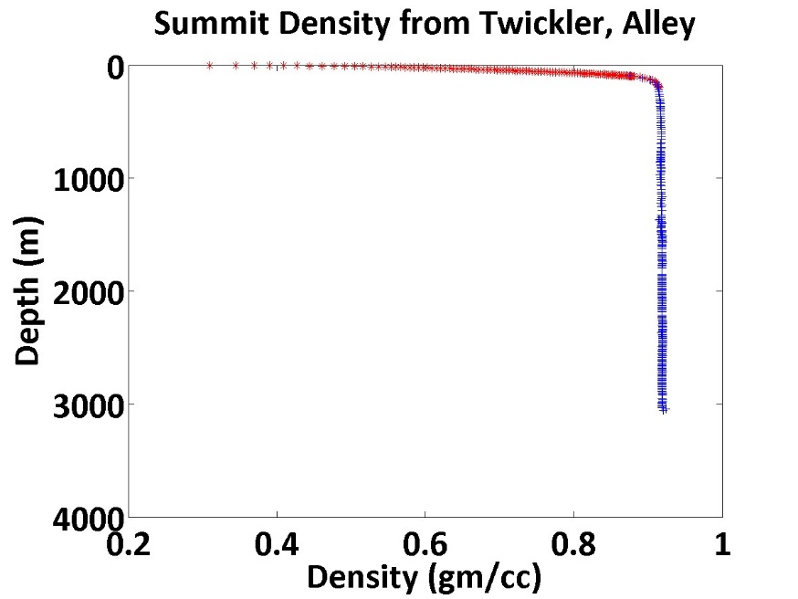

Figure 1. Smooth Density Curve for Summit (GISP)

There are two text files that contain the numerical data:

* [Twickler 1](http://bprc.osu.edu/rsl/UWBRAD/documents/twickler1_summit.txt)
* [Twickler 2](http://bprc.osu.edu/rsl/UWBRAD/documents/twickler2_summit.txt)

Shallow Cores and Pit Data

Bhattacharya was sent to Summit Station in 2004 to collect near surface physical property data. He sampled several shallow pits. He also made contact with a science technician working at Summit. The technician made monthly measurements of near surface density. These data are shown in figure 2. He also acquire several shallow core profiles (Figure 3). The locations of these data are in Bhattacharya’s field report. Files include

* [2004 Field Report](http://bprc.osu.edu/rsl/UWBRAD/documents/twickler2_summit.txt)
* [OSU Pit Data (including shallow cores)](http://bprc.osu.edu/rsl/UWBRAD/documents/OSU_pit_data.xls)
* [Science Tech Monthly data and OSU data](http://bprc.osu.edu/rsl/UWBRAD/documents/Science_techiedata_and_OSU.xls)

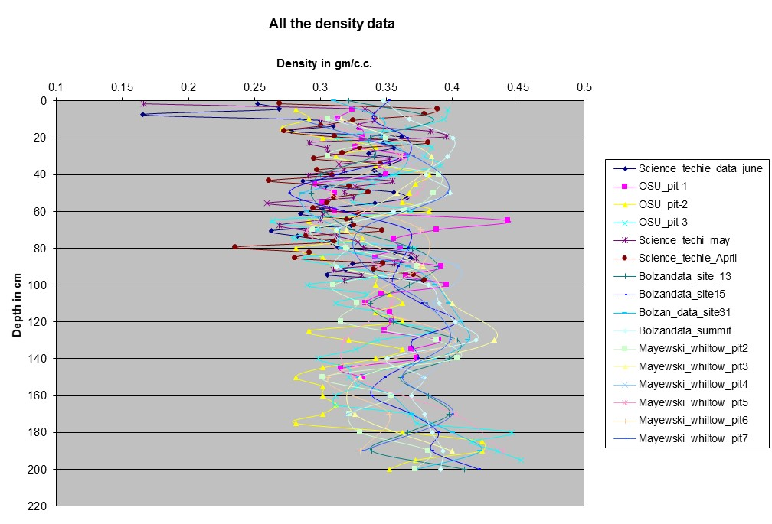

Figure 2. Ensemble of shallow pit data



Figure 3 Shallow Core data along with Bolzan Site 13 data.

Prior to the deep drilling work at GISP/GRIP2, Bolzan and Stroebel and Mayewski made measurements within about 20 km about the site. Available data are summarized in figure 2 and one of Bolzan’s 20 m cores is shown in figure 4.

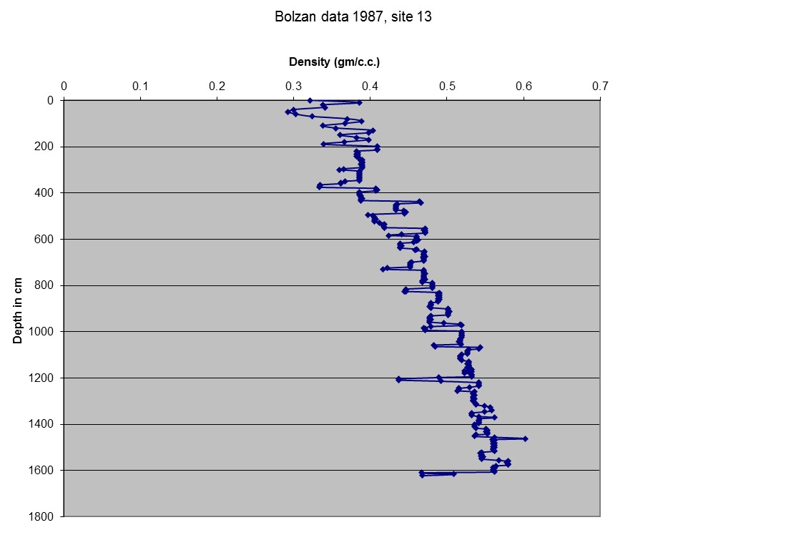 Figure 3. Site 13 Density Data from Bolzan

Files which include the Bolzan and Mayewski data are

* [Bolzan Witlow Data](http://bprc.osu.edu/rsl/UWBRAD/documents/Bolzan_and_Paul_Wiltow_pit_data.xls)
* [Bolzan and Jezek (map of site locations)](http://bprc.osu.edu/rsl/UWBRAD/documents/bolzan%20and%20jezek.pdf)